CSOPESY Semi-Major Output 1 | Prepared By: Gregory Cu  Created By: Neil Patrick Del Gallego, PhD
By group

Updated as of: Sept 18, 2026
General Instructions: An OS emulator needs a command interpreter and a display output.

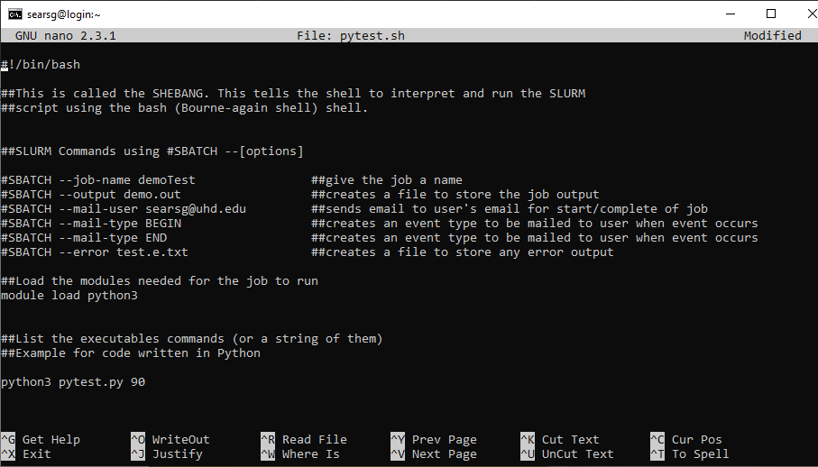

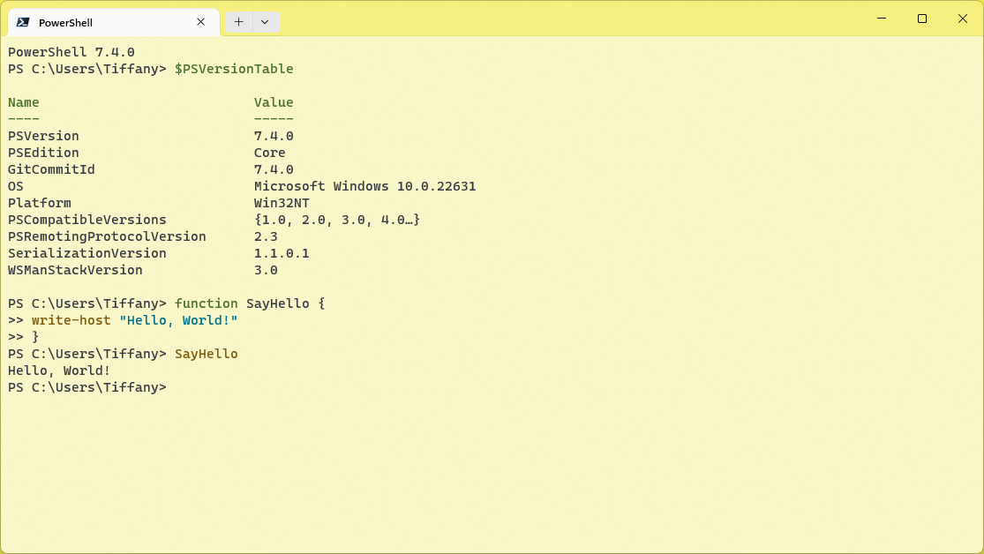

Shell Reference
Please refer to a general Linux/Windows powershell/Windows command line. This serves as a strong reference for the design of your command-line interface.

Checklist of Requirements
Your system must have ALL the following features implemented properly.

Requirement | An “OS emulator” that accepts a command input with display output
Description | 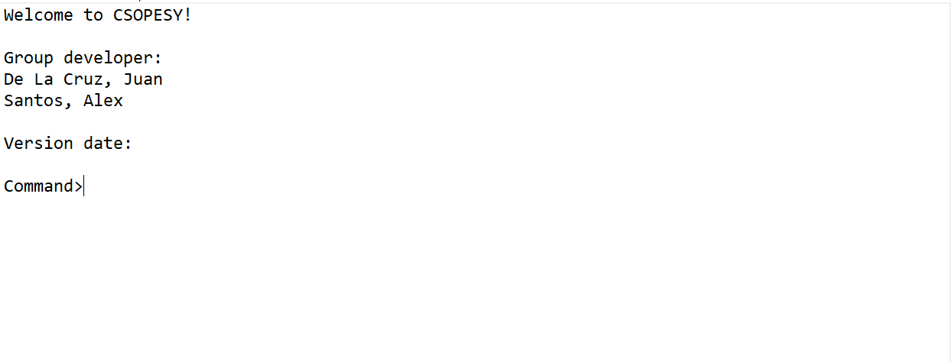  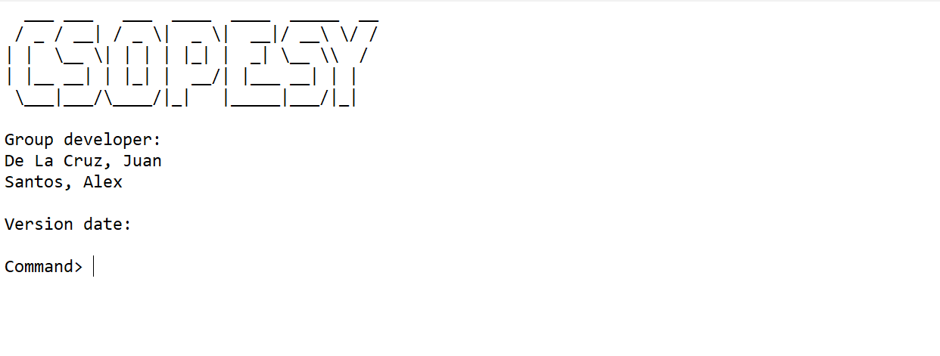  A main menu console that have the following features:  - Text marquee or ASCII graphics marquee  - Accept commands to change the behavior of the text marquee
Requirement | Command interpreter for the OS emulator that accepts the following commands
Description | From the main menu, the user can use the following commands:  - “help” – displays the commands and its description  - “start_marquee” – starts the marquee “animation”  - “stop_marquee” – stops the marquee “animation”  - “set_text” – accepts a text input and displays it as a marquee  - “set_speed” – sets the marquee animation refresh in milliseconds  - “exit” – terminates the console

ASSESSMENT METHOD
The project will be assessed through a black box quiz system in a time-pressure format. This is to minimize drastic changes or “hacking” your project to ensure the test cases are met. You should only modify the parameters and no longer recompile the project when taking the quiz.

Test cases, parameters, and instructions are provided per question, wherein you must submit a video file (.MP4), demonstrating your project. Some questions will require submitting PowerPoint presentations, such as cases explaining the details of your implementation.

IMPORTANT DATES
See AnimoSpace for specific dates.

Week 3 | Project submission

Submission Details
Aside from video files for the quiz, you need to prepare some of the requirements in advance, such as:
  - SOURCE - Contains your source code. Add a README.txt with your name and instructions on running your program. Also, indicate the entry class file where the main function is located. An alternative can be a GitHub link.
  - PPT – A technical report of your system containing:
  - Command recognition
  - Console UI implementation
  - Command interpreter implementation
  - Process representation
  - Scheduler implementation
  - Finding the balance between having a fluid refresh rate, and polling rate
    - Identify the recommended values for your current hardware
    - Identify the limits of your refresh and polling rate - wherein there is the presence of screen tearing and/or a noticeable delay in characters being recognized during typing
  - Video
  - Your video must be seamless and not cut. The minimum video quality should be at least 480p and a maximum of 720p. Please ensure that the font size of your IDE is large enough to be readable on video
  - Maximum video size should be limited to 1GB
  - You are not allowed to access/modify your code while performing the test case
  - The video should always show you pressing Run/Debug from your IDE, which should initialize your program. Once running, you are not allowed to exit from your program and attempt to modify your code
  - Not following upload instructions will invalidate your submission
  - Ensure that your MP4 is directly embedded in your PPTX. It should be reflected in your total file size

Grouping
This is a group project. Each group can have a maximum of four members. All members of the group should be in the same section.

Grading Scheme
- You are to provide evidence for each test case, recorded through video. Each test case will have some points allocated. The test cases will be graded as follows:
Functional
No points | Partial points | Full points
The CLI did not pass the test case. NO WORKAROUND is available to produce the expected output. | The CLI did not pass the test case. A workaround is available to produce the expected output. | The CLI passed the test case using varying inputs and produced the expected output.

